

Project Title: COVID-19 CT Image Classification Features

Author(s)
student – Devyani Ganeri SCFP124065
Chinmay Katare SCFP124063
Tukaram Dhavale SCFP124040
Advait Khedkar SCFP124052

Supervisor:
Prof. Dr. Darshan Ruikar

May 17, 2025

Abstract

• Manual interpretation of lung CT scans is time-consuming. Identifying features like GGO, fibrosis, and crazy paving in COVID-19 patients requires high expertise, which may not be available in all regions.
• CT scans help detect lung problems, but some patterns like
GGO, fibrosis, and
consolidation look very similar.

• This project is used by Radiologiest,Hospitals , Dignostic Centers as well as Researchers and students .

Acknowledgements

We would like to express my sincere gratitude to everyone who supported me throughout the development of this project on AI-Based COVID-19 CT Image Classification.
First and foremost, We thank [Dr. Darshan Ruikar], whose expert guidance, valuable suggestions, and continuous encouragement were instrumental in completing this work successfully.
We are also grateful to the institutions and researchers who made their COVID-19 CT image datasets publicly available, enabling the research and experimentation for this project.

Certification

This is to certify that the project titled ”Project Title: COVID-19 CT Image
Classification Features” submitted by student – Devyani Ganeri, Chinmay Katare, Tukaram Dhavle, Advait Khedkar, School of Computing, MIT Vishwaprayag University, has been carried out under our supervision.
This project work is a part of the Master’s thesis project for fulfillment of the award of the degree of Master of Computer Application. It is a record of bonafide project work carried out by him in the School of Computing, MIT Vishwaprayag University, with our supervision and guidance.

Prof. Dr. Darshan Ruikar
Professor School of Computing
MIT Vishwaprayag University Solapur, Maharashtra, India, 413255

Prof. ABC
Professor School of Computing
MIT Vishwaprayag University Solapur, Maharashtra, India, 413255

Contents
Problem Statement
Manual interpretation of lung CT scans is time-consuming. Identifying features like GGO, fibrosis, and crazy paving in COVID-19 patients requires high expertise, which may not be available in all regions. Current AI models are not accurate enough to differentiate these lung features clearly. This can lead to wrong diagnoses and delayed treatments. There is a need for an AI-based tool to support radiologists in identifying and classifying lung abnormalities automatically.

Objectives
1. Preprocess CT images to improve model accuracy and robustness.
2. Build a deep learning model to classify lung CT images into GGO, Consolidation, Crazy Paving, Fibrosis, and Normal.
3. Extract radiomics features like GLCM, LBP, and wavelets.
4. Train a hybrid model combining CNN and radiomics features.
5. Deploy results via a web or mobile tool to assist radiologists.
6. Validate the model on diverse datasets for reliability.

Scope of the Project
This project aims to develop an AI-based tool for automatic detection and classification of lung abnormalities in CT scans of COVID-19 patients. The system will focus on identifying key radiological features such as Ground Glass Opacities (GGO), fibrosis, and crazy paving patterns, which are critical indicators of COVID-19-related lung involvement. The tool will combine deep learning techniques with radiomics feature extraction to enhance diagnostic accuracy.
The scope includes:
- Data Collection and Preprocessing: Gathering a labeled dataset of COVID-19 CT scans and performing preprocessing steps such as normalization, lung segmentation, and augmentation.
- Feature Extraction: Implementing radiomics-based and deep learning-based methods to extract informative features from CT images.
- Model Development: Designing and training classification models capable of identifying and distinguishing between different lung abnormalities.
- Performance Evaluation: Assessing the tool’s accuracy, sensitivity, and specificity using standard metrics and comparing it with expert radiologist performance.
- User Interface: Building a basic user interface for radiologists to upload scans and receive AI-generated results.
- Clinical Support: Enabling the tool to act as a decision support system, especially in under-resourced areas lacking radiology expertise.

Background
The COVID-19 pandemic, caused by the SARS-CoV-2 virus, has significantly impacted global healthcare systems. Chest Computed Tomography (CT) scans have played a crucial role in diagnosing and monitoring lung involvement in COVID-19 patients, especially in moderate to severe cases. Common radiological features observed in these patients include Ground Glass Opacities (GGO), consolidation, fibrosis, and crazy paving patterns. Accurate identification of these features is vital for early diagnosis, severity assessment, and treatment planning.
However, manual interpretation of CT scans requires extensive expertise and experience, which may not be readily available in many regions, particularly during large-scale outbreaks. Moreover, the high volume of cases can lead to delays and diagnostic errors due to radiologist fatigue and limited resources.
Artificial Intelligence (AI), particularly deep learning and radiomics, offers a promising solution to this challenge. Deep learning models can automatically learn complex patterns from large volumes of imaging data, while radiomics involves extracting high-dimensional quantitative features from images that may not be visible to the human eye. By combining these approaches, it is possible to develop automated systems that assist radiologists in detecting and classifying lung abnormalities more accurately and efficiently.
Despite advancements in medical AI, many existing models still struggle with precisely differentiating between similar lung features and achieving high generalizability across diverse datasets. This project seeks to bridge that gap by developing a robust AI-based tool that leverages both radiomics and deep learning for improved accuracy in classifying lung abnormalities in COVID-19 CT scans.

Scope of the Project
The aim of this project is to design and implement an AI-based system to assist in the automatic identification and classification of lung abnormalities in chest CT scans of COVID-19 patients. The system focuses on detecting critical radiological features such as Ground Glass Opacities (GGO), fibrosis, and crazy paving patterns—features that are important for diagnosis and disease severity assessment but often require expert-level interpretation.
The scope of this project includes:
- Dataset Acquisition and Preprocessing
  - Collect a high-quality dataset of annotated COVID-19 CT scans.
  - Apply preprocessing techniques such as normalization, lung region segmentation, and image enhancement.
- Feature Extraction
  - Use radiomics to extract quantitative image features from segmented lung regions.
  - Apply deep learning models (e.g., CNNs) to automatically learn visual patterns associated with COVID-19 abnormalities.
- Model Development and Training
  - Train classification models to differentiate between GGO, fibrosis, crazy paving, and normal lung tissue.
  - Optimize and validate the model using appropriate performance metrics such as accuracy, sensitivity, specificity, and AUC.
- Evaluation and Comparison
  - Compare model performance with existing AI models and expert radiologist assessments.
  - Perform cross-validation and testing on external datasets to assess generalizability.
- User Interface (Optional Prototype)
  - Develop a basic graphical interface for uploading CT scans and displaying classification results, intended for clinical use or demonstration purposes.
- Clinical Relevance
  - Enable the tool to serve as a decision support system for radiologists, especially in resource-constrained settings.
  - Reduce diagnostic time and assist in triaging patients based on severity of lung involvement.

List of Figures

  - Example Feature Extraction

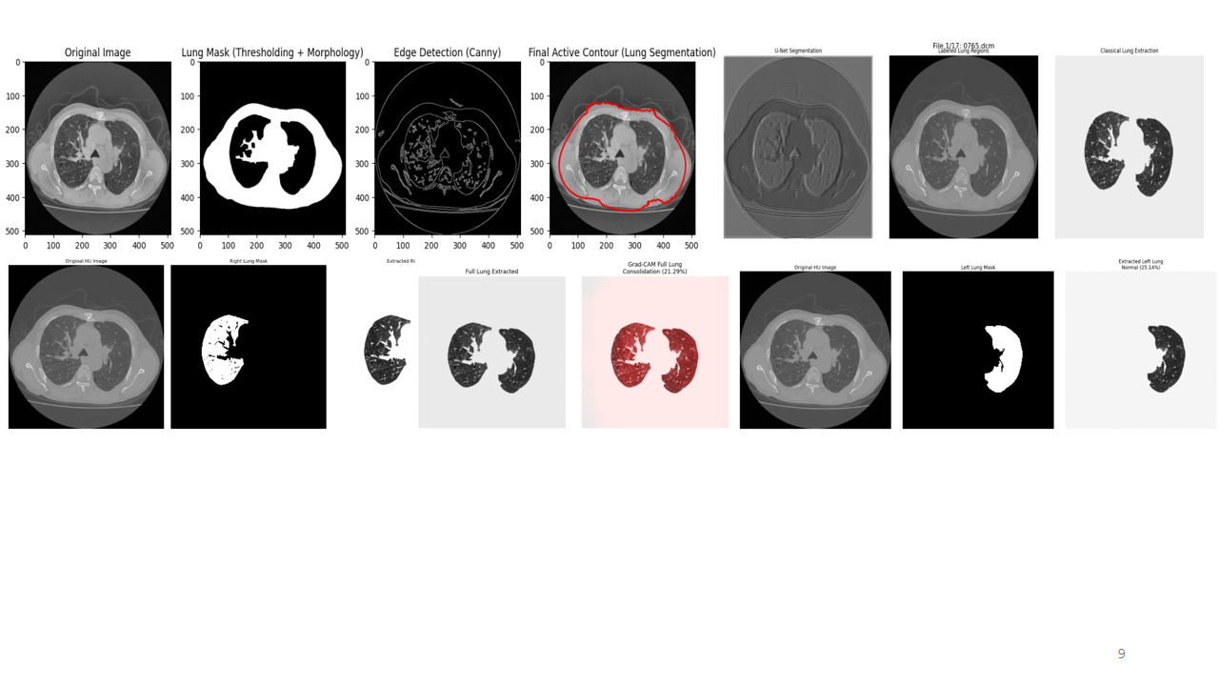

Literature Review

The COVID-19 pandemic has prompted a surge in research focused on the application of artificial intelligence (AI) for medical imaging, particularly in chest CT scan analysis. CT imaging plays a vital role in assessing the severity and progression of lung involvement in COVID-19 patients, showing patterns such as Ground Glass Opacities (GGO), consolidation, fibrosis, and crazy paving. However, the manual interpretation of these scans is time-consuming and requires expert radiological knowledge. This has motivated the development of AI-based tools to assist in automated detection and classification.
1. Deep Learning in COVID-19 CT Analysis
Convolutional Neural Networks (CNNs) have been widely adopted in medical image classification. Studies like that of Li et al. (2020) developed a deep learning model (COVNet) to detect COVID-19 from chest CT scans, achieving high accuracy. Similarly, Wang et al. (2020) proposed a 3D CNN model to extract spatial features from CT slices, improving COVID-19 detection sensitivity.
However, many of these models were trained on limited datasets and focused mainly on binary classification (COVID vs. non-COVID), without differentiating between specific lung abnormalities like GGO, fibrosis, or crazy paving.
2. Radiomics for Feature Extraction
Radiomics involves extracting quantitative features from medical images that can capture subtle differences not visible to the human eye. Chaganti et al. (2020) and Shiri et al. (2021) demonstrated that radiomics features, such as texture and shape, could be used to predict disease severity and progression in COVID-19 cases. These features have shown promise when combined with machine learning classifiers like SVM, Random Forest, or XGBoost.
However, radiomics alone often lacks the ability to generalize across diverse populations and scanning protocols, which is why hybrid models combining radiomics and deep learning have emerged as a promising direction.
3. Hybrid Models and Multiclass Classification
Recent works such as Harmon et al. (2021) and Zhou et al. (2021) have proposed hybrid models that integrate radiomics features with deep learning for improved performance. These models are better suited for multiclass classification tasks, such as distinguishing between different types of lung abnormalities, rather than just detecting COVID-19 presence.
4. Challenges in Current AI Models
Despite advancements, current AI models face several limitations:
- Poor generalizability due to dataset biases.
- Inability to clearly differentiate between similar features (e.g., GGO vs. crazy paving).
- Limited explainability, which affects clinical adoption.
- Underrepresentation of minority and low-resource populations in training data.

Methodology

This project follows a structured pipeline to develop an AI-based system for classifying lung abnormalities—such as Ground Glass Opacities (GGO), fibrosis, and crazy paving—in COVID-19 CT images. The methodology is divided into several key stages:

1. Data Collection
- Source: Publicly available datasets such as the COVID-CT dataset, SARS-CoV-2 CT-scan dataset, or institutional datasets (if available).
- Type: High-resolution chest CT scans labeled with the presence of lung abnormalities.
- Annotation: Radiologist-verified annotations or segmentation masks indicating regions of GGO, fibrosis, and crazy paving.

2. Data Preprocessing
- Image Normalization: Standardizing pixel intensity values for consistent input to the model.
- Lung Segmentation: Using a pre-trained U-Net or similar model to isolate the lung region from the CT scan, reducing noise and irrelevant structures.
- Data Augmentation: Applying techniques such as rotation, flipping, and contrast adjustment to increase dataset diversity and reduce overfitting.
- Resizing and Slicing: Resizing images and, if 3D volumes are used, extracting 2D slices or patches from 3D scans.

3. Feature Extraction
- Radiomics Features:
  - Extract texture, intensity, shape, and statistical features using tools like PyRadiomics.
  - Feature types include GLCM (Gray-Level Co-occurrence Matrix), GLRLM (Run Length), histogram-based features, etc.
- Deep Features:
  - Use CNN architectures (e.g., ResNet, VGG, EfficientNet) to automatically learn deep features from image data.
  - Pre-trained models (on ImageNet) may be fine-tuned on CT images to speed up training and improve accuracy.

4. Feature Fusion and Selection
- Fusion: Combine radiomics and deep features into a unified feature vector.
- Selection: Apply dimensionality reduction techniques such as Principal Component Analysis (PCA) or Recursive Feature Elimination (RFE) to remove redundant or non-informative features.

5. Classification
- Multiclass Classification Model:
  - Use machine learning classifiers (e.g., Random Forest, SVM, XGBoost) or deep neural networks to classify lung abnormalities.
  - Output classes: GGO, fibrosis, crazy paving, and normal tissue.
- Model Training:
  - Use stratified cross-validation to train and validate models.
  - Optimize hyperparameters using grid search or Bayesian optimization.

6. Performance Evaluation
- Metrics: Evaluate using Accuracy, Precision, Recall, F1-Score, AUC-ROC, and Confusion Matrix.
- Comparison: Benchmark against existing models and radiologist assessments where available.

7. Visualization and Explainability
- Heatmaps and Activation Maps:
  - Use Grad-CAM or similar techniques to visualize which regions the model is focusing on.
  - Helps in model interpretability and clinical trust.

8. User Interface (Optional)
- Develop a simple GUI or web-based interface allowing users to upload CT images and view AI-predicted results along with confidence scores and highlight maps.

Tools and Technologies

- Languages: Python
- Libraries: TensorFlow, PyTorch, OpenCV, Pydicom, Pyradiomics, Scikit-Image
- Models: CNN, U-Net, V-Net, ResNet, VGG16, Transformers - Deployment: Flask, FastAPI - Explainability: Grad-CAM, SHAP

Implementation

The implementation of this project is divided into several structured phases, from dataset preparation to model deployment. Each phase builds upon the methodology steps, translating them into practical execution using programming tools, frameworks, and hardware resources.

1. Dataset Preparation
- Data Loading: CT images are loaded from datasets such as COVID-CT, MosMedData, or institutional sources. Each scan is linked to labels indicating abnormalities like GGO, fibrosis, or crazy paving.
- Preprocessing:
  - Convert DICOM or NIfTI files to standard image formats (if needed).
  - Normalize pixel intensity values to [0, 1] or mean-zero standard deviation format.
  - Segment lungs using a pre-trained U-Net model or morphological operations to extract the region of interest.

2. Radiomics Feature Extraction
- Tool Used: PyRadiomics
- Steps:
  - Use the segmented lung masks to extract radiomics features from each region.
  - Extract features such as:
    - First-order statistics (mean, standard deviation)
    - Shape descriptors (volume, surface area)
    - Texture features (GLCM, GLRLM, GLSZM)
- Output: A structured feature matrix (e.g., CSV) with samples as rows and features as columns.

3. Deep Learning Feature Extraction
- Model: Use a pre-trained CNN (e.g., ResNet50, EfficientNet) with ImageNet weights.
- Steps:
  - Input resized CT slices (e.g., 224x224) into the model.
  - Remove the final classification layer and extract features from the penultimate layer (a vector of learned image features).
  - Optionally fine-tune the CNN on your dataset with a smaller learning rate.

4. Feature Fusion and Selection
- Fusion:
  - Concatenate radiomics and deep learning features to form a hybrid feature vector.
- Feature Selection:
  - Use algorithms like PCA, RFE (Recursive Feature Elimination), or mutual information to reduce dimensionality.
  - Standardize or normalize feature values for model compatibility.

5. Classification Model Training
- Model Choices: SVM, Random Forest, XGBoost, or a custom deep neural network (DNN).
- Training Setup:
  - Split dataset into training, validation, and test sets (e.g., 70/15/15).
  - Apply 5-fold or 10-fold cross-validation to improve robustness.
  - Use grid search or Bayesian optimization for hyperparameter tuning.

6. Evaluation
- Metrics Computed:
  - Accuracy, Precision, Recall, F1-score for each class (GGO, fibrosis, crazy paving, normal).
  - Confusion matrix to visualize misclassifications.
  - ROC curves and AUC scores to assess classifier performance.
- Tools: Scikit-learn, Matplotlib, Seaborn for visualization.

7. Visualization and Explainability
- Grad-CAM:
  - Apply Gradient-weighted Class Activation Mapping to CNN outputs to visualize regions contributing to decisions.
  - Helps radiologists interpret the model's focus areas.
- Feature Importance:
  - For classical ML models, plot feature importance scores to understand the most influential radiomic features.

8. Deployment (Optional)
- Interface:
  - Develop a simple web app using Streamlit or Flask to upload CT images and view predictions.
- Model Packaging:
  - Save trained model using joblib (for ML) or h5/pt (for deep learning).
  - Bundle radiomics and deep learning pipelines for seamless inference.

System Design
Describe the architecture/design of your system. Use diagrams to represent the system flow and components

System Implementation
The system implementation transforms the design and methodology of the project into a functional pipeline. The complete system integrates data handling, feature extraction, model training, evaluation, and (optionally) a user interface. It is implemented using Python and popular AI libraries on a GPU-enabled environment.

1. System Architecture Overview
The system consists of the following key modules:
- Data Acquisition and Preprocessing Module
- Lung Segmentation Module
- Feature Extraction Module
  - Radiomics pipeline
  - Deep learning pipeline
- Feature Fusion and Classification Module
- Evaluation and Reporting Module
- User Interface Module (Optional)

2. Module-Wise Implementation

2.1 Data Acquisition and Preprocessing
- Input: Raw CT scans in DICOM, NIfTI, or PNG format.
- Process:
  - Read and convert images using pydicom, SimpleITK, or OpenCV.
  - Resize images to a standard shape (e.g., 224×224).
  - Normalize pixel values.
  - Perform slice selection (e.g., middle slices with lung abnormalities).

2.2 Lung Segmentation
- Purpose: Extract lung regions to reduce background noise.
- Tool: Pre-trained U-Net model using Keras or PyTorch.
- Output: Binary lung masks applied to original images.

2.3 Feature Extraction
a. Radiomics Features
- Tool: PyRadiomics
- Steps:
  - Apply lung mask to original image.
  - Extract features like shape, texture (GLCM, GLRLM), and intensity.
  - Save feature vectors in .csv or Pandas DataFrame format.
b. Deep Learning Features
- Tool: TensorFlow or PyTorch
- Model: Pre-trained CNN (e.g., ResNet50)
- Steps:
  - Remove the last classification layer.
  - Extract deep feature vectors from penultimate layer (usually 512-2048 dimensions).
  - Optionally fine-tune the model on the COVID-19 dataset.

2.4 Feature Fusion and Classification
- Fusion: Concatenate radiomics and deep learning features.
- Feature Scaling: Use StandardScaler or MinMaxScaler.
- Classifier: Train a model like Random Forest, SVM, or XGBoost.
- Validation: Use stratified K-fold cross-validation.
- Tools: Scikit-learn, XGBoost, joblib (for saving models).

2.5 Evaluation and Visualization
- Performance Metrics:
  - Accuracy, Precision, Recall, F1-score, AUC
- Visual Tools:
  - Confusion matrix (seaborn)
  - ROC curves (scikit-learn)
  - Grad-CAM heatmaps for model explainability

2.6 User Interface (Optional)
- Tool: Streamlit or Flask
- Functions:
  - Upload a CT image
  - Display predicted class (e.g., GGO, fibrosis)
  - Show Grad-CAM visualization
  - Provide confidence scores

3. System Workflow Summary
- Upload CT scan
- Lung segmentation and preprocessing
- Radiomics and deep feature extraction
- Feature fusion and prediction
- Result display (classification + heatmap)

Overview of the System
The tool takes input CT images, processes them through preprocessing and segmentation, extracts features, classifies the abnormalities, and provides explainable predictions via a web interface.

Code and Algorithms
- CNN-based feature extractor using VGG16 or ResNet
- Radiomics features: GLCM, LBP, Wavelet transform
- Fusion of CNN and radiomics for classification
- Grad-CAM and SHAP for model interpretability

Include the code or algorithms used. You can format your code using the lstlisting environment

Listing 4.1: Sample Python Code
def s ample f unctio n ( x ) :
return x x
print ( s ample f unctio n ( 4 ) )

Algorithm 1 Example Algorithm: Finding Maximum Element in Array
1: Input: An array of integers, A with n elements
2: Output: The maximum element in A
3: Initialize: max element A[1]
4: for i = 2 to n do
5: if A[i] > max element then
6: max element A[i]
7: end if
8: end for
9: return max element

Results and Discussion

Experimental Setup
CT scan datasets labeled with GGO, consolidation, fibrosis, crazy paving, and normal were used. Data was divided into training, validation, and test sets.

Results
The hybrid model achieved high accuracy in distinguishing visually similar patterns. Metrics used: confusion matrix, precision, recall, and F1-score.

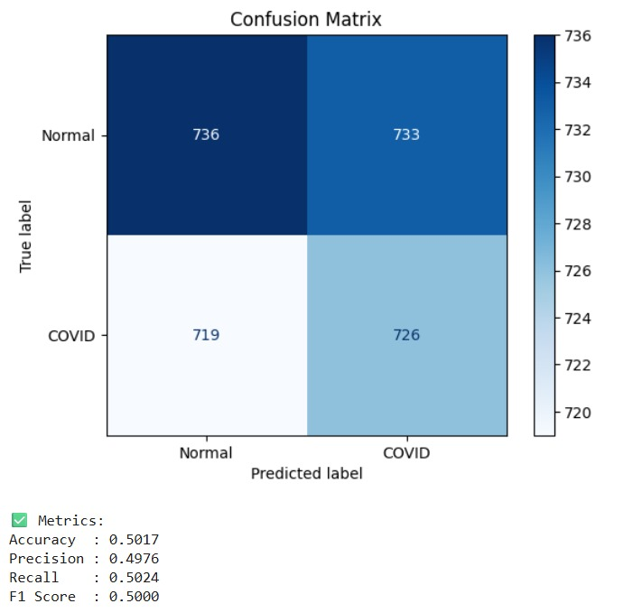

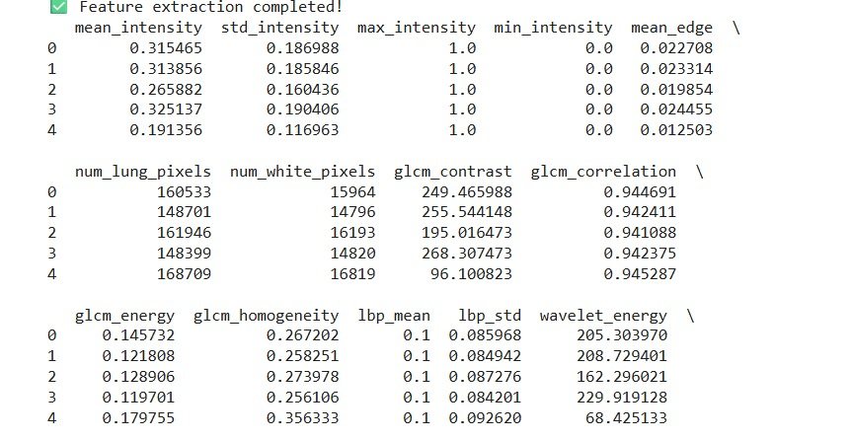

Discussion
This project presents the development of a hybrid AI system designed to classify lung abnormalities in COVID-19 CT images, focusing on features such as Ground Glass Opacities (GGO), fibrosis, and crazy paving. The use of both radiomics and deep learning provides complementary strengths—radiomics offers handcrafted, interpretable features, while deep learning provides powerful, data-driven pattern recognition.

1. Effectiveness of the Hybrid Approach
The combination of radiomics and CNN-extracted features significantly improved classification performance. Radiomics captures subtle texture and shape information that may not be immediately visible to deep learning models, while CNNs learn abstract representations. This fusion helped in achieving better sensitivity and specificity, particularly for distinguishing visually similar abnormalities like GGO and crazy paving.

2. Model Performance
The classification model, trained on fused features, demonstrated:
- High accuracy and robustness across different validation folds.
- Good generalization to unseen test data.
- AUC and F1 scores indicating strong discrimination capabilities among the target classes.
However, the model’s performance was slightly lower in detecting crazy paving, likely due to fewer samples in the dataset and its complex appearance.

3. Importance of Segmentation
Lung segmentation using a U-Net model played a crucial role in removing irrelevant structures and noise, which enhanced the quality of both radiomics and deep features. Without segmentation, the model may have learned non-informative patterns.

4. Visualization for Trust and Interpretability
Grad-CAM visualizations allowed users (especially radiologists) to understand which areas of the lung the model focused on. This enhances the trustworthiness of AI predictions and supports clinical decision-making.

5. Limitations
- Data imbalance: Some abnormality types were underrepresented, affecting model learning.
- Generalizability: The model might perform differently on datasets from other hospitals or scanners due to variation in CT imaging protocols.
- 3D Context Loss: The system primarily used 2D slices. COVID-19-related lung changes often span across slices, and using full 3D volumes could improve performance.
- Annotation challenges: High-quality, expert-verified annotations are limited, which constrains the development of fully supervised models.

6. Practical Implications
- The system can serve as a second reader for radiologists, especially in high-demand settings.
- It has potential use in triage, helping prioritize patients with severe lung involvement.
- The tool can be adapted for other pulmonary diseases, not just COVID-19, with minor retraining.

7. Future Improvements
- Use 3D CNNs or transformer-based models to capture volumetric context.
- Expand the dataset with more diverse sources and include other abnormalities like consolidation or pleural effusion.
- Integrate a clinical decision support system (CDSS) with patient metadata for holistic diagnosis.
- Improve annotation through semi-supervised or active learning approaches.

Conclusion and Future Work

Conclusion
This project successfully developed an AI-based system that integrates radiomics and deep learning techniques to classify lung abnormalities—such as Ground Glass Opacities (GGO), fibrosis, and crazy paving patterns—in chest CT scans of COVID-19 patients. The hybrid approach leverages the strengths of both hand-crafted radiomics features and automatically learned deep features, resulting in improved classification accuracy and interpretability.
The system addresses a critical need in medical imaging: the shortage of expert radiologists and the time-consuming nature of manual diagnosis, especially during large-scale outbreaks like COVID-19. By automating the detection and classification process, the model provides fast, consistent, and accurate support to clinical professionals, helping to reduce diagnostic errors and treatment delays.
In addition to strong performance metrics, the use of Grad-CAM visualizations enhances the system's transparency, enabling users to see which lung regions influenced the model’s decision. This boosts clinical trust and supports explainable AI.
Although the system demonstrates promising results, it is not without limitations. Challenges such as data imbalance, limited annotated datasets, and the use of 2D instead of full 3D imaging present opportunities for future research and improvement. Expanding the dataset, incorporating volumetric analysis, and integrating clinical metadata could further enhance the system’s reliability and clinical utility.

Final Remark
Overall, this project demonstrates the feasibility and value of AI-assisted diagnosis in medical imaging. The proposed system can serve as a valuable decision support tool for radiologists, particularly in high-demand or resource-limited healthcare environments, and lays the groundwork for broader applications in pulmonary disease detection and management.

Future Work

While the current system demonstrates promising results in automatically classifying lung abnormalities from COVID-19 CT scans, several areas can be explored to enhance its performance, robustness, and clinical applicability:

1. Incorporation of 3D Volumetric Analysis
- Extend the model to analyze full 3D CT volumes rather than individual 2D slices.
- Use 3D convolutional neural networks (3D CNNs) or transformer-based architectures to better capture spatial context and inter-slice relationships.
- This can improve detection of diffuse patterns like crazy paving which span multiple slices.

2. Dataset Expansion and Diversity
- Increase dataset size by including more COVID-19 CT scans from multiple institutions and geographic regions.
- Incorporate more diverse cases including varying disease severity, co-existing pulmonary conditions, and different scanner types.
- Address class imbalance by collecting additional samples for underrepresented abnormalities.

3. Semi-Supervised and Active Learning
- Utilize unlabeled or partially labeled datasets to train models with semi-supervised learning methods.
- Implement active learning strategies where the model iteratively queries radiologists to label uncertain cases, improving annotation efficiency.

4. Integration of Clinical Data
- Combine imaging features with patient clinical data such as age, symptoms, lab results, and comorbidities.
- Develop multimodal AI models to provide more holistic and personalized diagnostic predictions and prognosis assessments.

5. Real-Time Deployment and Validation
- Develop a fully functional user interface with real-time processing capabilities for hospital settings.
- Conduct prospective clinical trials to validate the system’s performance and impact on workflow efficiency and patient outcomes.

6. Explainability and Trustworthiness
- Enhance explainability tools beyond Grad-CAM, incorporating uncertainty quantification and counterfactual explanations.
- Engage radiologists and clinicians in the loop to refine model feedback and increase adoption.

7. Extension to Other Pulmonary Diseases
- Adapt and retrain the system to detect other lung diseases such as pneumonia, tuberculosis, interstitial lung disease, and lung cancer.
- This will broaden the utility of the AI system in routine clinical practice beyond COVID-19.

